**ENGR 102 Sect #__516__ Lab 2a - team**

**100**

**Reading assignment:**

|  |  |
| --- | --- |
| **Lecture Slides** | **L01- L02** |
|  |  |

***Attention!!***

***For submission: pdf/word file and all py-files as asked in the assignment. If you do pictures by the phone –please make sure that we can read them. Do not submit multiple picturess, collect them all into one file (word or pdf). . You will be allowed to resubmit and reupload HW as many times as you want to within the due date/time, only last submission will be graded. No late submissions.***

***For submission you may use this file as a template: rename file including your name. Do not forget to put your name inside of this file as well.***

***If you are submitting py- files, make sure that they have a header. Use a team header for this assignment.***

**To do in a lab as a team**

Use a team header and put all team members to all files.

**What do you submit?**

Lab2a_team#.pdf or word with all answers, derivations, screenshots, conclusions for activity 1 and activity 2. *TA’s will assign the team number in the class.*

And any py-files you produced. You have to submit your py-files. Points will be taken off for missing py-files.

*The purpose of this activity is to practice writing simple programs that require multiple variables and to ensure you understand the idea of interpolation. The individual assignment will build on this program.*

You are to work together as a team to write a short program that performs the linear interpolation. Here is the scenario.

: Team Activity – Linear Interpolation Code

The purpose of this activity is to practice writing simple programs that require multiple variables, and to ensure you understand the idea **of interpolation**. One of the individual assignments in Lab Assignment 2b will build on this program.

You are to work together as a team to write a short program that performs linear interpolation

***Please refer to the posted material on Linear Interpolation*.**

**From presentation:**

* Solving for $y$, we have an expression for unknown $y$ in terms of the $(x,y)$ coordinates of Point 1 and Point 2 and in terms of the given value of $x$

$y=\left(\frac{y_{2}-y_{1}}{x_{2}-x_{1}}\right)(x-x_{1}$)+ $y_{1}$

* What variables do we need?
  + Let’s use $x_{1}$ and $y_{1}$ for Point 1 location
  + Let’s use $x_{2}$ and $y_{2}$ for Point 2 location
  + Let’s use $x_{0}$ for the given $x$ value of the point of interest
  + Let’s use $y_{0}$ for the unknown $y$ value that we seek
  + We may decide to use other variables, but this will get us going
* What steps do we take?
  + Assign values to $x_{1}$ and $y_{1}$
  + Assign values to $x_{2}$ and $y_{2}$
  + Assign $x_{0}$ its value

Calculate $y_{0}$ based on the expression developed above

* Let’s make sure that we are performing Linear Interpolation not Linear Extrapolation
* To do that, check to make sure that $x_{0}$ is between $x_{1}$ and $x_{2}$ prior to performing the other calculations

**How do we implement in Python?**

* Now the program sequence looks like this:
  + Assign values to $x_{1}$ and $y_{1}$
  + Assign values to $x_{2}$ and $y_{2}$
  + Assign $x_{0}$ its value
  + If $x_{0}$ is between $x_{1}$ and $x_{2}$ (inclusive), do the following:
    - Calculate $y_{0}$ based on the expression we developed
    - Output or store the value of $y_{0}$
    - End program
  + If $x_{0}$ IS NOT between $x_{1}$ and $x_{2}$ (inclusive), do the following:
    - Print error message to screen
    - End program

You are to work together as a team to write a short program that performs linear interpolation. Here is the scenario:

You are an engineer at NASA monitoring the International Space Station (ISS) as it orbits the Earth at a constant rate of speed. You want to be able to predict where the ISS is above the Earth at any point in time. To do this, you take a measurement of how far around the Earth the ISS has traveled at two points in time. Assume that NASA has very precise instruments for determining position. You note the time of the first position, and a short while later (before the ISS has completed one revolution), you take a second measurement for how far the ISS has traveled, again noting the time.

Now, it’s your job to reconstruct the position of the ISS at any time between the first and second measurements. Since you assume the ISS is moving at a constant speed, this calculation can be found via linear interpolation. As a team, determine what variables you will need to use, and what formula(s) you will need to perform this calculation. *You should use variables for all of the values that could change.*

**Part 1. [50 pts]**

The first measurement was taken at time $t=10$ minutes, and the second was taken 45 minutes later. At the first measurement, the ISS was 2,025 kilometers past Houston, TX. At the second measurement, the ISS was 23,025 kilometers past Houston.

* Write a program that determines, for any time between 10 and 55 minutes, where the ISS will be (in terms of kilometers past Houston). The time to evaluate at should be a variable in your program. The program should print both the time and the position at that time to the screen, with a line describing what is being output (see example output below). You should test your program at various times and make sure the results seem reasonable.
* For your final program that you submit, output the position at time of **25 minutes**. (Next week, we will see how you can read in numbers from a user, but for now, just assume it is a fixed number of minutes.)

Questions to think about: What happens if you enter $t=0$ minutes as the time of interest? What is output as the position at that time? How do you interpret this result? Should the position at $t=0$ minutes be at Houston? Suggestion: Hand draw a sketch of position versus time and plot the two known observations. Now, predict from the sketch what the calculated position will be for $t=0$ minutes or for $t=1500$ minutes.

**Put your derivations, screen shots of your code, and outputs here**

How to name a file? Something like that, for example HW2a_team#_ Act1. py

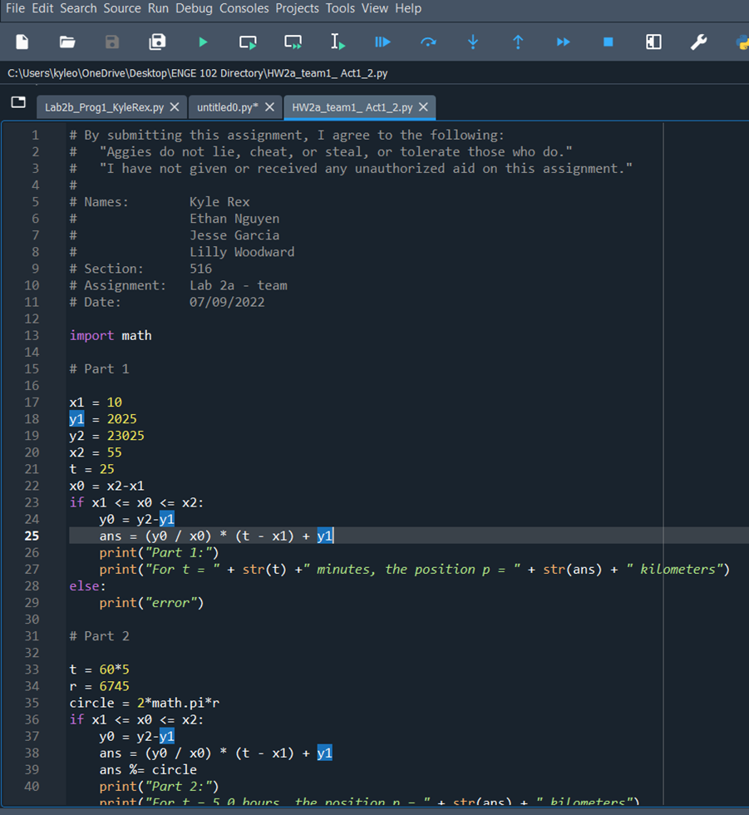

**Part 2. [50 pts]**

Now, let’s make this a bit more interesting. The ISS orbits in a circle with **radius 6,745 kilometers**. Use the same observed data as before: **at 10 minutes**, the ISS is 2,025 kilometers past Houston, and **at 55** minutes, the ISS is 23,025 kilometers past Houston. Assume its speed is constant.

When a time is specified, we want to report the *distance from Houston*, not the total distance traveled. So, every time the ISS passes Houston, its “distance” from Houston gets reset to zero (0). So, if you go far into the future, say at a time of 5 hours, simple linear interpolation will not produce the result we want. You’ll need to modify your code to report distances correctly regardless of the time.

Here are a few hints for Part 2:

* If we use the same code from above and enter a time of 5 hours, we calculate a distance greater than the orbit’s circumference. (Estimate that calculated distance from your plot.)
* However, we want to report a position of the ISS between 0 kilometers and the numerical value of the orbit’s circumference expressed in kilometers.
* We could do this using a series of subtractions. We could perform successive subtractions of the circumference from the total position until the result was between 0 kilometers and the numerical value of circumference in kilometers. That would represent the position with respect to Houston.
* If we were clever, we could also use “modulo division” in Python. (Remember from Lecture 1?)
* Questions to think about: Is this linear “extrapolation”? If so, why are we are we using linear extrapolation despite all the warnings not to use it? Is there ever a case when using linear extrapolation is acceptable?
* Another Question to think about: Will the code for Part 2 output the correct answer for time (t) of 25 minutes as was used in Part 1?

**Put your derivations, screen shots of your code, and outputs here**

How to name a file? Something like that, for example HW2a_team#_ Act2.py

You can combine both act 1 and 2 into one py-file and name it as HW2a_team#_ Act1_2.py

**Example output:**

Part 1:

For t = 25 minutes, the position p = 9025.0 kilometers

Part 2:

For t = 5.0 hours, the position p = 10218.078642554414 kilometers

**What do you submit?**

* Lab2a_team#.pdf or word with **all answers, derivations, screenshots, conclusions** for activity 1 and 2.
* And any py-files you produced.

**Conclusion:**

As a team we created a program that performs liner interpolation to find where the ISS is above the Earth at any point in time. We did this by finding the distance the ISS had traveled around the world at two different points of time. Using variables and formulas, we constructed, and assuming that the ISS is moving at a constant speed, using linear interpolation we were able to reconstruct the position of the ISS at any time between the two points of time. In this case we found the position between the 10-to-55-minute mark at 25 minutes which is 9025.0 kilometers. Then, because we were trying to calculate the position of the satellite for a period of time that it revolved around more than once, we reconstructed the code to include the equation of the circle and the given radius. We used this to calculate to position of the ISS after 5 hours which is 10218.078642554414 kilometers.